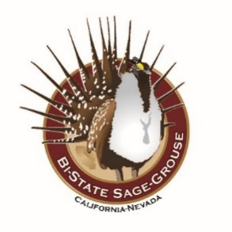

BI-STATE LOCAL AREA WORKING GROUP
Draft MEETING AGENDA

Date: Monday January 6th, 2020
Time: 1:00PM-3:30PM
Location: Bridgeport Memorial Hall
73 N School St. Bridgeport, CA 93517

- Introductions & Review Agenda (15 minutes)

- USFWS Update (Steve Abele) (15 minutes)
  - Listing decision update
  - LAWDP water allotment strategy talks

- Bi-State Tribal Natural Resource Committee Updates (15 minutes)
  - BTNRC meetings
  - Traditional Ecological Summit

- EOC Update (15 minutes)
  - New Service 1st agreement
  - Commitment letters updated
  - TEK Summit funding
  - USGS monitoring and research funding

- TAC Update (Shawn Espinosa-15 minutes)
  - 2012-2018 Accomplishment Report published
  - Integrated Lek database
  - 2020 TAC priorities

- USGS Research & Monitoring Updates (Seth & Becca-15 minutes)
  - Bi-State Integrated Population Model Updates
  - Late summer fieldwork and fall captures
  - Parker translocation
  - Egg oiling

- Partner in the Spotlight: Friends of the Inyo (Jora Fogg-15 Minutes)
  - Learn about FOI’s role in BSSG conservation efforts

- Bi-State Accomplishment Summary (Amy Sturgill-15 Minutes)
  - Work completed in 2019
  - Work prioritized for 2020

- LAWG Satisfaction Survey and Future Goals Discussion (All-30 Minutes)

- Partner Updates & Schedule Next Meeting

